

LANDING PAGE

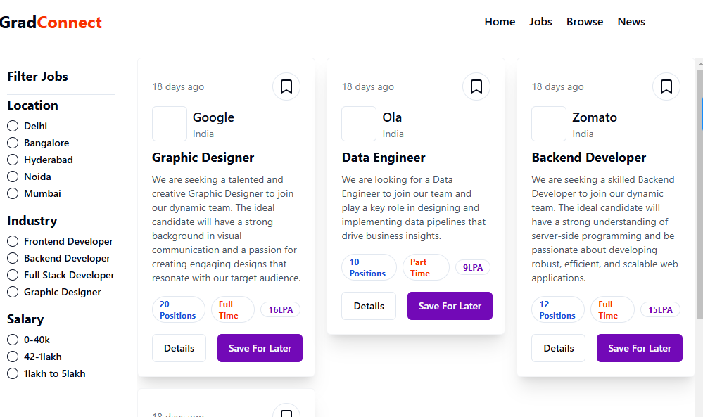

JOB PAGE

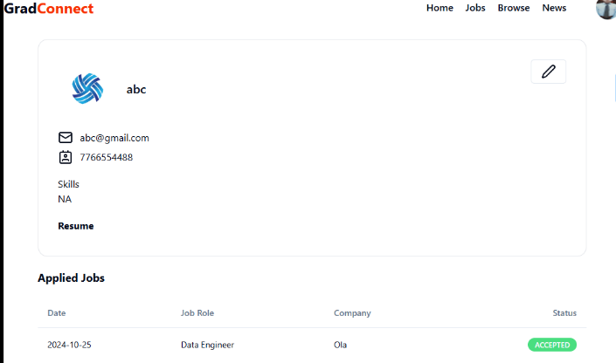

PROFILE PAGE:

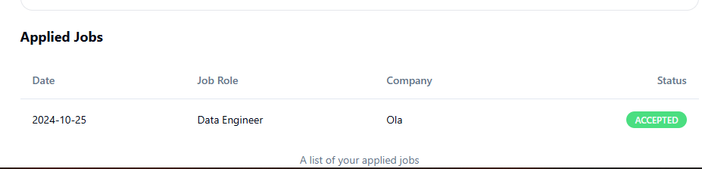

Application Status Page

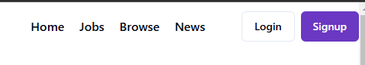

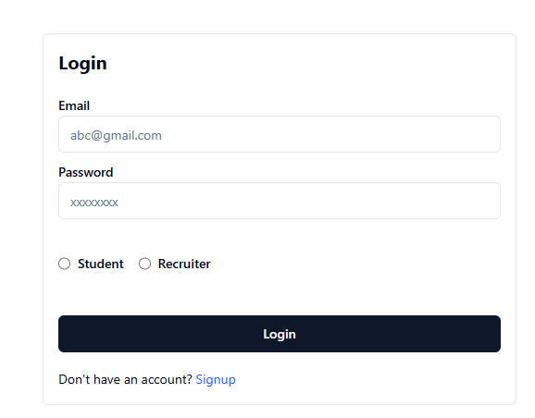

Login Page:

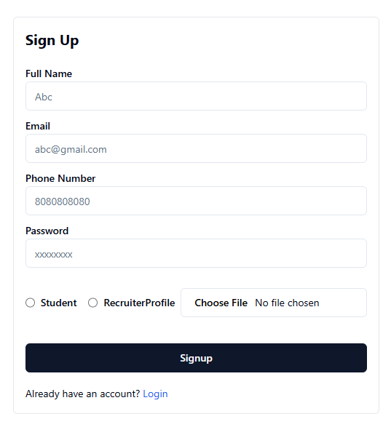

Sign up page For new User:

While Entering wrong email and password:   
  
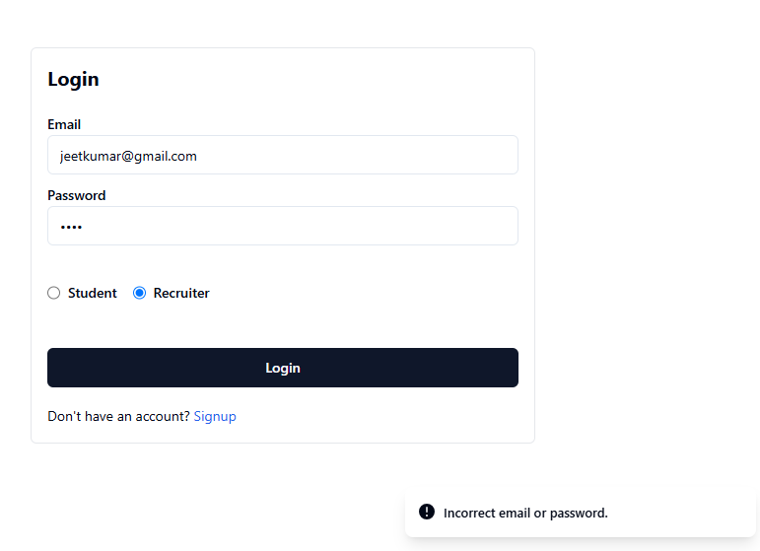

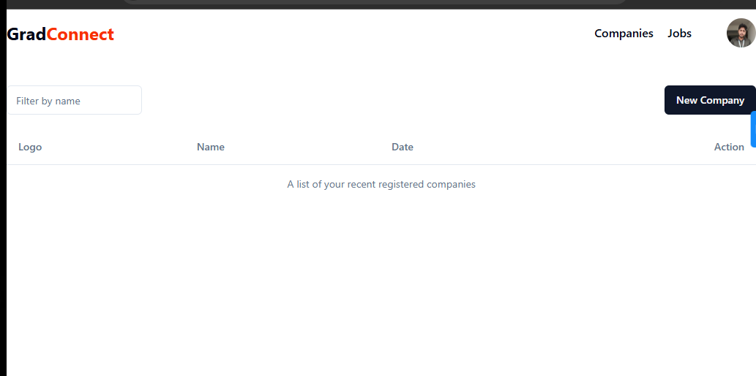

Admin Profile:

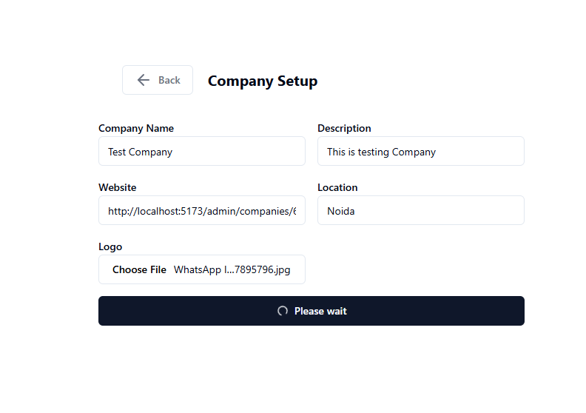Company Setup Page:

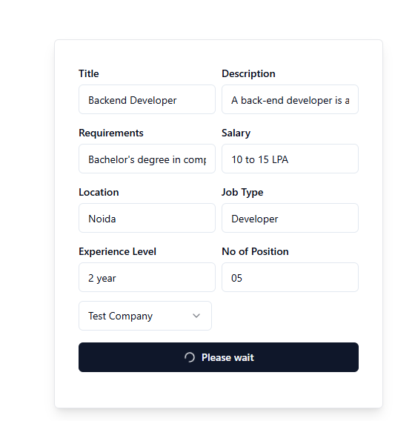

Adding new Jobs For the Student as a recruiter:

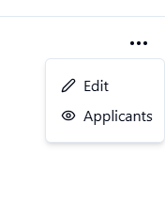

As A admin he can see the number of applicants who have applied for this job or position

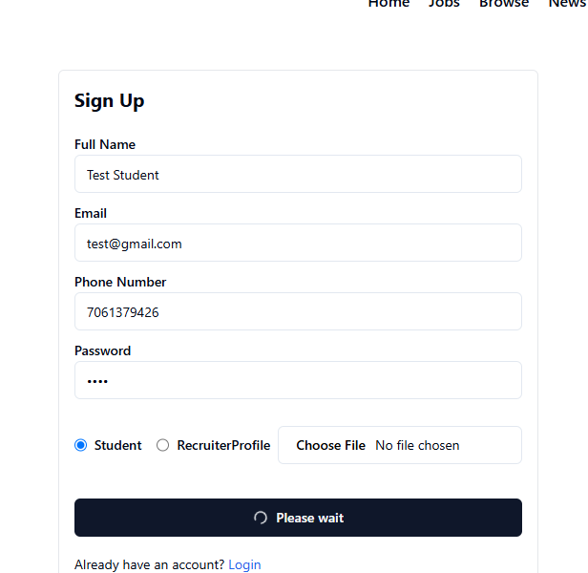

Sign up as a Student

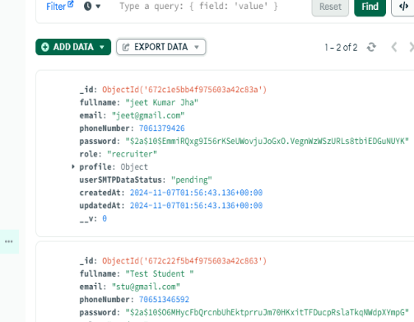

Databse

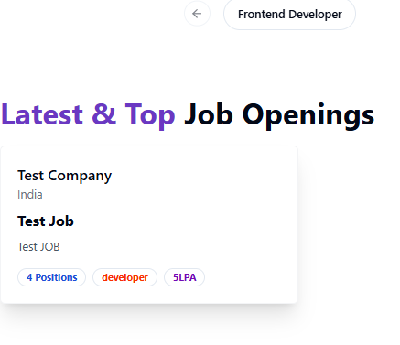

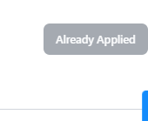

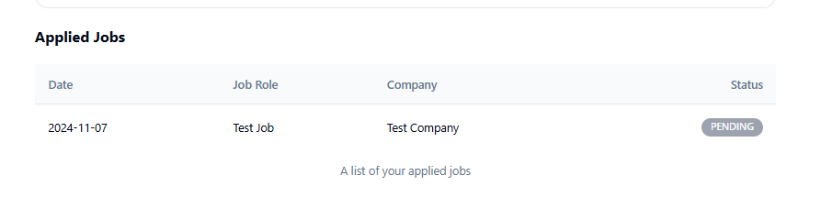

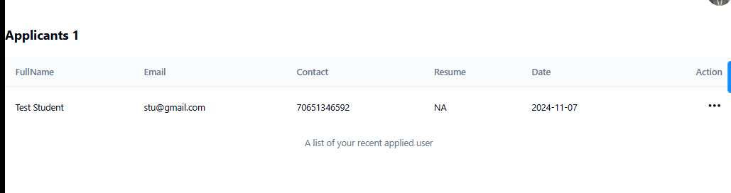

As a admin I can see the applicant

Admin/ recruiter can accept and reject : according to that student will get email.

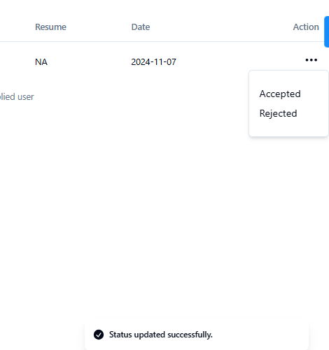

Status Changed:  
  
As of now I have Build This Page only The development is in Process I will be hosting this project soon on the site.